Topic: Wildlife Conservation
Teacher Version

NSE Domain | Module | Unit | Topic
Ecological Security | Nature and Environment | Protecting the Environment | Wildlife Conservation

Suggested Levels: S1-S3

Summary of the Learning Topic
The learning topic aims to enhance students’ understanding about the giant panda conservation work in our country and raise their awareness of the importance of biodiversity conservation.

Learning Tasks:
- Part 1 – Pre-viewing: Students are guided to understand more about the ecological security domain and activate their prior knowledge about giant pandas.
- Part 2 – Video Viewing: Students view the video “Preserving Pandas” about the conservation of giant pandas to understand more about our country’s efforts in protecting the endangered wildlife.
- Part 3 – Post-viewing: Students read the article “Panda’s Rise Shows Biodiversity Improving” as a follow-up to find out more about the development of giant panda preservation. Students are then guided to understand the text structure and language items related to an article and a timeline.
- Part 4 – Speaking: Students research information online about an endangered/a vulnerable animal in China and prepare a 3-minute presentation about the conservation work of the endangered/vulnerable animal in our country.
- Part 5 – Extended Learning Activity: Students create a digital story about an endangered animal in China and design an itinerary for a volunteer programme to support the conservation of vulnerable species of our country.

Learning Objectives:

Content
To explore concepts related to the ecological security, i.e.
- biodiversity;
- the conservation of endangered species;
- the impact of human activities on ecology and the environment; and
- the importance of and our country’s efforts in biodiversity conservation

Language
To develop language knowledge and skills, e.g.
- listening, speaking, reading/viewing and writing skills;
- text structures of different text types (i.e. a video, an article, a timeline, a digital story, an itinerary); and
- the use of the simple past and the present perfect tenses to talk about past events
Part 1 – Pre-viewing
- Introduction
Ecological security, including water, land, atmosphere and biological species security, is the basic condition for human survival and development. Ecological damage, environmental pollution and epidemics have been posing threats to national ecological security. The conservation work of giant pandas has made significant contributions to the conservation of endangered wildlife and safeguarding national ecological security. Find out more about the giant pandas and the conservation work in our country that helps them thrive.

- Discussion
- How much do you know about giant pandas? Write down your thoughts in Boxes (a) – (d).
(b) Diet
What do giant pandas eat?
Mainly bamboos

- Habitat
Where can we find giant pandas?
China, Sichuan/
They can survive in places of cold weather./
Accept any reasonable answers.

(d) Conservation
What are the potential threats to giant pandas’ natural habitat?
Climate change and human activities/ Accept any reasonable answers.

(c) Behaviour
What skills do giant pandas possess?
They can climb and swim very well./
Accept any reasonable answers.

Friendship, peace, good luck
- Pandas were sent to other countries as gifts in the 1950s – 1980s. What do pandas symbolise in Chinese culture?
Part 2 – Video Viewing

- Watch the video “Preserving Pandas” and complete the flowchart below.
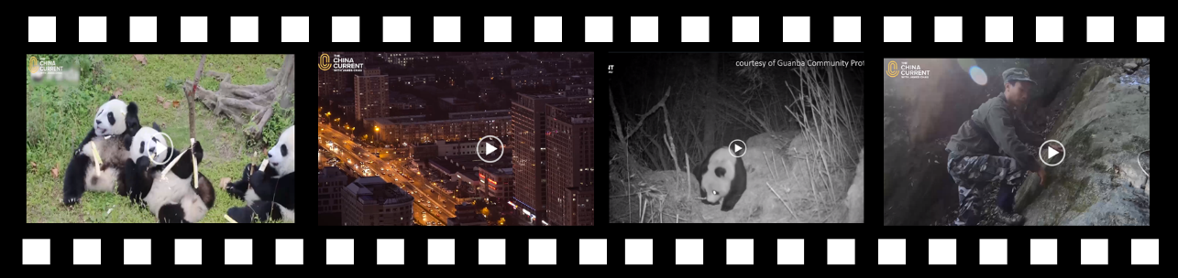
https://chinacurrent.com/education/article/2021/4/22977.html
Problem

Threats to Giant Pandas
- Human (a) encroachment and (b) disturbance to pandas’ natural habitat
- (c) Poaching of wild pandas in the 70s and 80s

Solution

Giant panda conservation efforts by (d) scientists and (e) forest rangers
Better (g) research foundation on conservation of giant pandas
China’s stricter (f) protection measures on giant pandas

Efforts and achievements of the Chinese government
in preserving giant pandas

The Guanba Community Protected Area, also known as the “World’s No.1 County for Pandas” or the (j) “Valley of the Panda”, has the (k) highest concentration of giant pandas in the whole world.
Giant panda habitats can be found in the following provinces in China:
- Gansu
- (h) Shaanxi
- (i) Sichuan

- What do forest rangers do to support the conservation of giant pandas?
Rangers patrol in the forest each month to stop illegal poaching and check on infrared
camera traps that silently trigger as an animal passes.

- Which of the following are the challenges faced by the forest rangers? Tick the appropirate boxes. (You can choose more than one.)
Sleeping in shelters with makeshift beds | Difficulty in finding a base camp
Not having enough food | Getting ready and setting off for  work very early in the morning
Hiking along dangerous paths | Risks of being attacked by wild animals

- What do you think about the job of being a forest ranger? Why do you think the forest rangers in China persist in their job despite the challenges?
Accept any reasonable answers.

- What can students do to support the conservation work of giant pandas in our country?
Accept any reasonable answers.

Part 3 – Post-viewing
- Reading

- You are going to read an article about the conservation of giant pandas.

- By studying the title of the article “Panda’s Rise Shows Biodiversity Improving”, predict the writer’s view on the present status of giant pandas.

The writer is _______________ about the conservation work of giant pandas.
- (A) angry
- (B) disappointed

- (C) positive
- (D) unsure

The use of the words “Rise” and “Improving” shows that the writer is positive about
the conservation work of giant pandas.
- Explain your answer.

- Study the word “Biodiversity”.

Bio- divers(e) -ity
Prefix

- Words related to “Bio-”:
_____________________

- Meaning:

_____________________

_____________________

Root

- Words related to “diverse”:

_____________________

- Meaning:

_____________________

______________________

Suffix

- Part of speech:

____________________

- Meaning:

____________________

____________________

e.g. biology, biological
e.g. many, different, various
noun

Showing variety, with different types
A quality/ state
Life

The variety/different types of life/living things on Earth
- What does the word “Biodiversity” refer to?

- Read the article and answer the questions.

Panda’s Rise Shows Biodiversity Improving
5  10  15  20  25  30  35  40 | A giant panda plays after snow at Shenshuping base of the China Conservation and Research Center for the Giant Panda in Wolong National Nature Reserve, Southwest China’s Sichuan province, December 17, 2020.  The removal of the giant panda from the list of endangered animals indicates that nature reserves are performing their duties in preserving the nation’s biodiversity, an official said.  “The panda population in the wild has risen to about 1,800, which reflects their improved living conditions and China’s efforts in keeping their habitats integrated,” Cui Shuhong, head of the Ministry of Ecology and Environment’s Department of Nature and Ecology Conservation, said at a news conference on Wednesday.  The fourth census on China’s panda population by the National Forestry and Grassland Administration found 1,864 pandas lived in the wild by 2013, up from 1,596 in 2003 when the third census was taken.  Since the 1970s, China has conducted four panda censuses, one every decade, which focused on Sichuan, Shaanxi and Gansu provinces, where the majority of pandas are located.  China’s protection methods have included setting up panda reserves, relocating residents from panda habitats, training local people to be rangers and breeding pandas in captivity.  In 2018, the Giant Panda National Park Administration based in Sichuan was established. The park, which connects fragmented habitats, also takes in parts of Shaanxi and Gansu and covers 87.5 percent of the country’s entire panda population, according to the park’s website.  A staff member from the China Conservation and Research Center for the Giant Panda in Wenchuan county, Sichuan, said, in the 2000s China solved three main problems of panda breeding: the difficulty for pandas to enter a mating cycle, impregnation and the low survival rate of cubs.  “Since 2006, we have managed to breed an increasing number of pandas in captivity, and about nine of them survived after being released into the wild,” he said.  “Despite that, the giant panda still remains under the State-level protection plan,” said the staff member, who only gave the name Zhang.  Wang Wenbin, a spokesman for the Foreign Ministry, said at a news conference on Thursday: “It is good to see more rare species active in China, such as Siberian tigers in the northeast, and the recent migration of Asian elephants to the north. Nowadays in China, there is a code of conduct among the government and people to respect and protect nature.”  In 2016, the International Union for Conservation of Nature announced that the giant panda’s status had been changed from “endangered” to “vulnerable” on the Red List of Threatened Species.  However, Chinese wildlife authorities remained cautious about the change at that time, saying it was still too early to remove giant pandas from the list of endangered animals based on the actual situation in China.
Source: https://www.chinadaily.com.cn/a/202107/09/WS60e78417a310efa1bd660ab5.html

4. What is the role of the China Conservation and Research Center for the Giant Panda in Wolong National Nature Reserve?
It helps preserve the nation’s biodiversity. / It helps in conservation work of giant pandas.
(h) _______________________ (i) _______________________
Vulnerable
Endangered
The giant panda’s status on the Red List of Threatened Species (2016):
(f) 2006
Since 2006, (e) the number of pandas in captivity has increased. About nine of them survived after being released into the wild.
1,596 pandas (d) lived in the wild.
(c) 2003
5. Complete the timeline below using information from the text.
1970s006
Since the (a) 1970s, China (b) has conducted four panda censuses, one every decade.
(g) 1,864 pandas lived in the wild.
2013
- Decide if the information in the following statements is “True”, “False” or “Not Given”.

What were the challenges in panda breeding? | Please tick () the appropriate box.
 | True | False | Not Given
- It was not easy to get pandas into the mating cycle.
- The female pandas had difficulty in getting pregnant.
- The pandas had difficulty in finding their partners.
- The panda cubs had a high survival rate.

- Find a word in lines 24-29 which means “keeping an animal in a designated place”.
Captivity (line 28)

- What is the Chinese wildlife authorities’ view on the decision to remove the giant pandas from the Red List of Threatened Species in 2016?

- (A) Careful
- (B) Ironic
- (C) Neutral
- (D) Supportive

- Why is biodiversity conservation important for safeguarding ecological security?
Accept any reasonable answers.

- What are the effective ways to raise students’ awareness of biodiversity conservation?
Accept any reasonable answers.

- Language Focus: Simple Past and Present Perfect

- Study the following sentences from the video “Preserving Pandas” and the article “Panda’s Rise Shows Biodiversity Improving”.

- In the following sentences, underline the verbs in the simple past tense and circle the verbs in the present perfect tense.
Poaching in the 70s and 80s actually killed off many of the wild pandas here.

Once, the panda’s natural habitat covered a range extending just south of present-day Beijing all the way into Myanmar and Vietnam. But, human population growth has reduced and split up habitats.

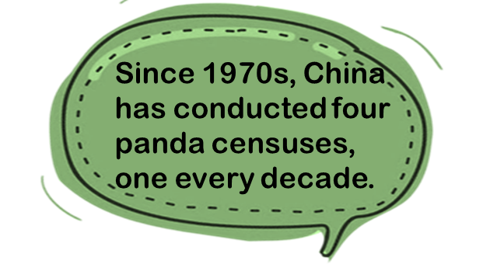

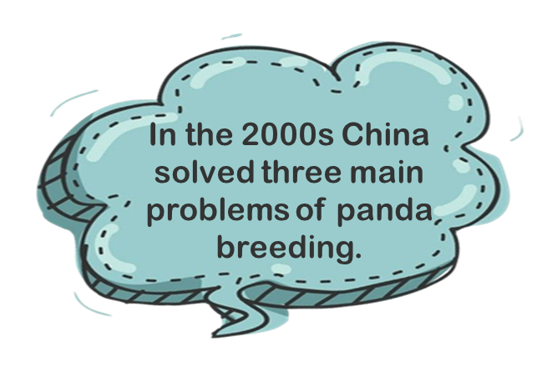
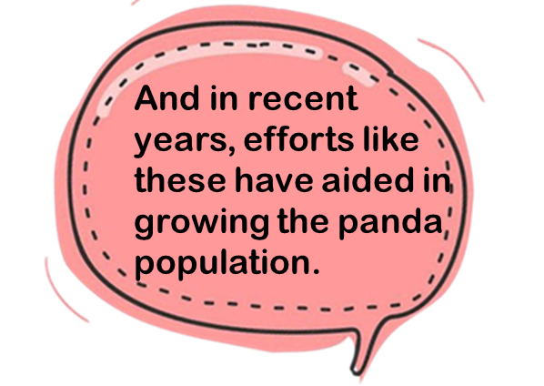
- Write the verbs in the table below.

Simple Past | Present Perfect
- covered  - killed  - solved | - has reduced  - has conducted  - have aided

- Discuss with your classmates the difference between the use of the simple past and the present perfect to talk about the past.
Simple past: Use of time words “In the 2000s”, “in 2016”, “in 2018”, etc.
Present perfect: Use of the time word “since”; the past action is connected to
the present.

Part 4 – Speaking
- The Chinese government has implemented multiple measures to protect the country’s most vulnerable wildlife through habitat protection, scientific research and captive breeding. Giant pandas, Asian elephants, Hainan gibbons, Siberian tigers, Chinese pangolins, crested ibises, Tibetan antelopes and milu deer are examples of key species under conservation.
As the Chairperson of the school’s Conservation Club, you are going to give a 3-minute presentation about endangered/vulnerable animals in China and the conservation work in our country at the school assembly.
Research information online about an endangered/a vulnerable animal in China. You may include the following in the presentation :
- Introduction of the animal
- Threats faced by the animal
- Conservation work done by the Chinese government
- Things we can do to support the conservation work of endangered species
Plan and organise your ideas by using the note sheet below:
- Introduction of the animal (e.g. habitat, diet, behaviour)

- Threats faced by the animal

Accept any reasonable answers.
Accept any reasonable answers.

- Name of the endangered/vulnerable species:

____________________________

Photo of the species
Accept any reasonable answers.

- Conservation work done by the Chinese government

- Things we can do to support the conservation work of endangered species

Accept any reasonable answers.

Accept any reasonable answers.

Part 5 – Extended Learning Activity

- Suggested cross-curricular learning activities with Computer Literacy and/or Science/Geography.

- Creating a digital story about an endangered animal.
In groups, students write a short story on one of the following topics and record their story using an app. Encourage them to add illustrations, captions, background music and sound effects to add impact to the story.
- A story about the last remaining animal of an endangered species
- An adventure of an endangered animal that escapes the clutches of a poacher
- A soliloquy of an endangered animal whose habitat was being destroyed by humans

- Becoming a conservationist!
To help support the conservation of the most vulnerable wildlife of our country, students design an itinerary for a volunteer programme about animal conservation in Hong Kong.
- Students explore the different panda volunteer programmes organised by the panda bases in Chengdu, Dujiangyan, Bifengxia and Wolong to understand more about the existing conservation work promoted by our country.
- Students then identify an endangered/a vulnerable species of our country from the conservation list of Ocean Park.
- Students design an itinerary for the volunteer programme that engages volunteers in taking care of and learning fun facts about the species.

